**COMPETITORS ANALYSIS**

Nestlé currently has over 2000 brands with a wide range of products across a number of markets, including coffee, [bottled water](https://en.wikipedia.org/wiki/Bottled_water), [milkshakes](https://en.wikipedia.org/wiki/Milkshake) and other [beverages](https://en.wikipedia.org/wiki/Beverages), [breakfast cereals](https://en.wikipedia.org/wiki/Breakfast_cereal), [infant foods](https://en.wikipedia.org/wiki/Baby_food), [performance and healthcare nutrition](https://en.wikipedia.org/wiki/Sports_nutrition), [seasonings](https://en.wikipedia.org/wiki/Seasoning), [soups](https://en.wikipedia.org/wiki/Soup) and [sauces](https://en.wikipedia.org/wiki/Sauces), frozen and refrigerated foods, and [pet food](https://en.wikipedia.org/wiki/Pet_food). Milo is one of the product that manufacturing by Nestlé. It is a [chocolate](https://en.wikipedia.org/wiki/Chocolate) and [malt](https://en.wikipedia.org/wiki/Malt) powder typically mixed with hot [water](https://en.wikipedia.org/wiki/Water) and [milk](https://en.wikipedia.org/wiki/Milk) to produce a beverage. ‘Milo’ was derived from the famous ancient athlete [Milo of Croton](https://en.wikipedia.org/wiki/Milo_of_Croton), after his legendary strength. It produced by [Nestlé](https://en.wikipedia.org/wiki/Nestl%C3%A9), but Milo was originally developed by Australian inventor [Thomas Mayne](https://en.wikipedia.org/wiki/Thomas_Mayne_(inventor)) in 1934. However, there are still many other companies that offers similar products in the market. These are called competitors. Ovaltine and Horlicks are the examples of competitors of Nestlé Milo.

Ovaltine is a brand of [milk](https://en.wikipedia.org/wiki/Milk) flavouring product made with [malt](https://en.wikipedia.org/wiki/Malt) extract, [sugar](https://en.wikipedia.org/wiki/Sugar), [whey](https://en.wikipedia.org/wiki/Whey) (liquid remaining after [milk](https://en.wikipedia.org/wiki/Milk) has been [curdled](https://en.wikipedia.org/wiki/Curd) and strained) and some flavour also have [cocoa](https://en.wikipedia.org/wiki/Cocoa_solids). Ovaltine was developed in [Bern, Switzerland](https://en.wikipedia.org/wiki/Bern,_Switzerland), where it is known by its original name, Ovomaltine (from *ovum*, Latin for "egg", and *malt,* which were originally its main ingredients). Soon after its invention, the factory moved out to the village of [Neuenegg](https://en.wikipedia.org/wiki/Neuenegg), a few kilometres west of [Bern](https://en.wikipedia.org/wiki/Bern), where it is still produced. It is a registered [trademark](https://en.wikipedia.org/wiki/Trademark) of [Associated British Foods](https://en.wikipedia.org/wiki/Associated_British_Foods), is made by Wander AG, a subsidiary of [Twinings](https://en.wikipedia.org/wiki/Twinings), which acquired the brand from [Novartis](https://en.wikipedia.org/wiki/Novartis) in 2002. However, Ovaltine has lost its popularity to [Nestlé Milo](https://en.wikipedia.org/wiki/Nestl%C3%A9_Milo). It is sold in [Tetra Pak](https://en.wikipedia.org/wiki/Tetra_Pak) cartons for cold serving and widely available in shops and supermarkets, yet it has a low profile compared to similar beverages in the market.

Horlicks is a sweet [malted milk](https://en.wikipedia.org/wiki/Malted_milk) hot drink developed by founders [James](https://en.wikipedia.org/wiki/Sir_James_Horlick,_1st_Baronet) and [William Horlick](https://en.wikipedia.org/wiki/William_Horlick). It was first sold as "Horlick's Infant and Invalids Food", soon adding "aged and travelers" to their label. In the early 20th century it was sold as a powdered [meal replacement](https://en.wikipedia.org/wiki/Meal_replacement) drink mix. The main ingredient is sugar (around 44%). Other ingredients include wheat flour, malt extract, malted barley, milk solids, minerals, salt, vitamins, protein isolate.

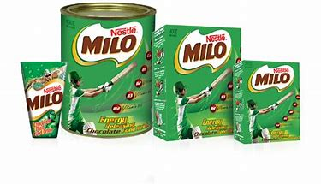 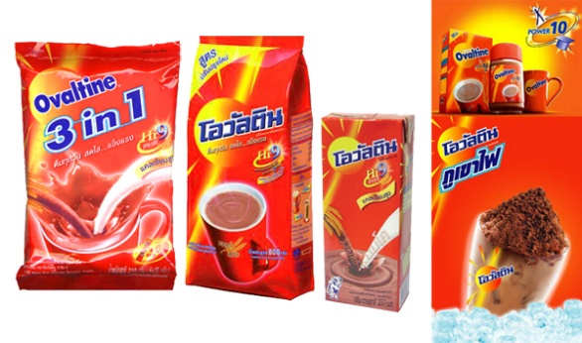

Picture 1: Example of packaging of Milo Picture 2: Example of Packaging of Ovaltine

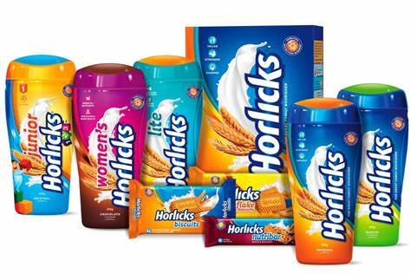

Picture 3: Example of Packaging of Horlicks

Table below shows the differences between Milo, Ovaltine, and Horlicks.

Table : Differences between Milo, Ovaltine and Horlicks.

|  |  |  |  |
| --- | --- | --- | --- |
|  | Milo | Ovaltine | Horlicks |
| Manufactured | only by Nestle | By several manufacturers | By [GlaxoSmithKline](https://en.wikipedia.org/wiki/GlaxoSmithKline), [Malaysia](https://en.wikipedia.org/wiki/Malaysia), [Australia](https://en.wikipedia.org/wiki/Australia), [New Zealand](https://en.wikipedia.org/wiki/New_Zealand), [Hong Kong](https://en.wikipedia.org/wiki/Hong_Kong), [Bangladesh](https://en.wikipedia.org/wiki/Bangladesh), [India](https://en.wikipedia.org/wiki/India), [Sri Lanka](https://en.wikipedia.org/wiki/Sri_Lanka) and [Jamaica](https://en.wikipedia.org/wiki/Jamaica). |
| Attracted  area | Most famous in Southeast Asian countries and Australia | Most famous in Europe | Most Famous in South Asia, Hong Kong and India |
| Price | Moderate | Low | High |

-<https://en.wikipedia.org/wiki/Milo_(drink)>

-<https://en.wikipedia.org/wiki/Ovaltine#See_also>

-<https://en.wikipedia.org/wiki/Horlicks>

-<https://abettermandotblog.wordpress.com/2017/07/23/milo-ovaltine-or-horlicks-the-malted-milk-wars/>

-<https://www.bing.com/images/search?q=packaging+horlicks&qs=n&form=QBIDMH&sp=-1&pq=packaging+horlicks&sc=018&sk=&cvid=3F31B1A184894325A4B6262EDFB7AAF6>

-<https://www.bing.com/images/search?q=packaging%20milo&qs=n&form=QBIR&sp=-1&pq=packaging%20milo&sc=814&sk=&cvid=CDE3B3008BB14451A6D23781DCB68A40>

-<https://www.bing.com/images/search?q=packaging%20ovaltine&qs=n&form=QBIR&sp=-1&pq=packaging%20ovaltine&sc=218&sk=&cvid=991D59240DA0485CBBD9C47B44765C3C>